Arts Council England:
Developing Your Creative Practice
Application template – October 2020
Created by The Uncultured
the-uncultured.com // @_theuncultured_

User notes
This template is a direct copy and paste of all of the information in Grantium.
Total: 7 pages
- To access this in Grantium, you will first have to complete the Eligibility Questionnaire.
- You cannot submit this to ACE, but instead use this as a place to write your answers and then copy and paste your answers into Grantium.

DEVELOPING YOUR CREATIVE PRACTICE

Developing Your Creative Practice offers awards from £2,000 to £10,000 to support development opportunities for individual cultural and creative practitioners based in England.
The application form asks you a series of questions about different parts of your project including quality, management and finance. This gives us information about you, the development work you want to do and your budget. We will use the information you give us in your application form to decide whether we will offer you a grant.
The next two screens are autofilled with information you have already provided. If you need to make any amendments to this information, you will need to go back to the Applicants section and edit your applicant profile.
Throughout the application portal, any items marked * must be completed.
All our text boxes have a character limit. Please stick to this character limit as any additional text won’t be saved.
Please read the Guidance for applicants before making your application

APPLICANT DETAILS AND ADDRESS INFORMATION

Auto-populated in your account
If you need to update anything – see this guide

ACTIVITY DATES
Please enter the start and end dates for your activity.

You must allow enough time to plan your activity and for us to process your application.

We can not fund any goods or services that you have bought, ordered or contracted before we can make a decision on your application.

Activity start date:
Activity end date:

*How did you hear about Developing Your Creative Practice?
How did you hear about Developing Your Creative Practice?
Dropdown

ACTIVITY FOCUS
What do you want to focus on? If your application is successful we will ask you to reflect back on this at the end of your project as part of your final activity report.
*Tick as many as you feel are relevant to your project:
- building new networks for future development/presentation of work
- creating new work
- experiment with new collaborators
- international travel to explore other practice or work with mentor
- professional development activities
- research and development time to explore practice and take risks

YOUR WORK

Think about:
- the main focus of your creative or cultural activities;
- your main creative achievements to date – for example, exhibitions, productions, publications, and so on;
- any important commissions you’ve received;
- important pieces of work you’ve completed;
- if you’ve worked with any established creative or cultural partners;
- any other information relevant to your track record; and
- whether you have shown that you’re at the right stage in your practice to make a step change, and benefit from a development opportunity.

* Please tell us about yourself and your creative practice
(up to 1,800 characters including spaces)

YOUR DEVELOPMENT

*Tell us about the developmental opportunity you want to undertake, what you hope to get out of it, and how you will go about it.

Think about:
- how you will seek out opportunities that will benefit your development
- how ambitious your activity is. We can fund small, one-off opportunities (such as a research trip), but we’re more interested in supporting extended periods of development which give you the time to really explore and work in new ways
- how you will manage the activity successfully, and whether what you want to do is realistic and well-planned
- if you have plans in place to access the networks you want to work with

(up to 1,500 characters including spaces)

*Why is this important for your practice at this point, and how will this help create future opportunities?

Think about:
- what your main aims for the project are
- why this is the right point to take some development time
- what you want this development to lead to; and
- what will be different about your practice as a result of this development

(up to 1,500 characters including spaces)

PUBLIC ENGAGEMENT
Developing Your Creative Practice furthers Arts Council England’s charitable purposes of improving the knowledge, practice, accessibility and understanding of arts and culture by supporting the development of independent creative practitioners to take them to the next stage in their practice, which will benefit audiences in England in the longer term.

*If you were to receive a grant to develop your creative practice, how will this be beneficial to the public (either now or in the future)?

- Making work to present/show to the public
- Reaching new audiences through exploring new ways of working
- Developing networks to increase opportunities to present work
- Other (please specify)

OUTCOMES

* Our 10-year strategy, Let’s Create, has three Outcomes. Tell us which of our Outcomes, listed below, you think your project will contribute to.
Outcomes:

* Choose options that apply from the following list:
- Creative People: Everyone can develop and express creativity throughout their life
- Cultural Communities: Villages, towns and cities thrive through a collaborative approach to culture
- A Creative and Cultural Country: England’s cultural sector is innovative, collaborative and international

YOUR WORK – ATTACHMENTS

We’d like to see an example of your work to give us a sense of your practice.
This could be a video, a sound clip, some images, or anything you think demonstrates your work. You can either provide a web link or attach a document.

We also need one supporting document, written by someone other than you that supports the quality of your practice. This can be a review, external views of your work or a letter of support from an organisation or partner you have worked with.

See our Guidance for applicants for more detail on what we expect to see here.

You can use the links below to upload your documents, or link. We need:
- one document to demonstrate your work (either as a web link or an attachment) and;
- one supporting document (an attachment)
Your document can be up to 10MB, and we accept PDF, MS Word, MS Excel, MS PowerPoint and JPEG files.

Upload/add links.
FINANCE
The Finance section will ask you to complete a budget for your activity. Please read the expenditure section of the guidance carefully before you begin.

Key things to remember about budgets:
- We need to be able to see how you have worked your figures out, so please break them down clearly.
- Your budget should be for the total cost of the activity you are applying to do.

AMOUNT REQUESTED

*Please tell us the total amount you are requesting from us, including any personal
access costs (£):

*How much of this request is for your personal access costs (£):
*If there are extra costs relating to your own access needs, or those of the people you are working with, to help you deliver your project and manage your grant online, include them in this figure. For example, payment for a sign language interpreter to help you manage your project.
* Do you, or does your organisation object to receiving National Lottery funding for religious reasons?
Choose one option that applies from the following list:
- Yes
- No

To find out more about personal access costs, please read the information sheet Access support.

EXPENDITURE
Please enter all the expenditure for your project on this page.
The table at the top of the page is a snapshot of the information you are entering, and will calculate your total expenditure for you as you work. This table is not editable.

The details about each item of expenditure that you add will be shown in the list at the bottom of the page. You should make sure that you show how your figures have been calculated in the 'Description' field. For example, you should show the number of days and the daily rate for any fees shown.

To add an expenditure line
To add each expenditure line, click the 'Add new item' icon on the left of the screen. To add more than one line of expenditure, use the 'Save and Add another' button.
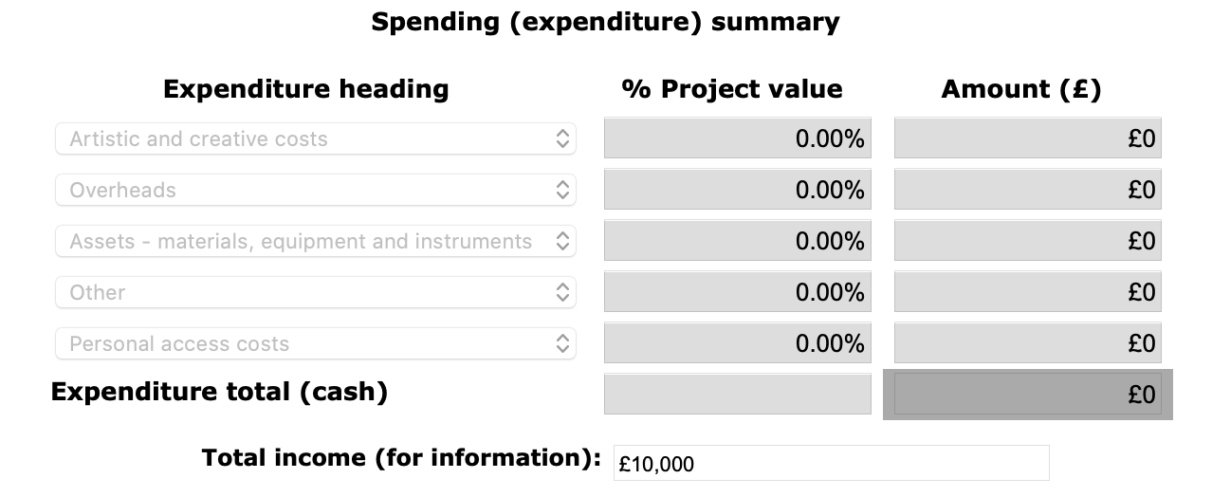
Screenshot of the top section.

Expenditure type* | Description | Amount (£)

*Each expenditure must be categorised as either:
- Artistic and Creative Costs
- Overheads
- Assets – buildings, equipment, instruments or vehicles
- Other
- Personal access costs

ACTIVITY PLAN
Use the tool below to outline how you will plan your development period, including key milestones.

To create the table click the ‘Add new item’ icon on the left of the screen to add an activity or key milestone. To add more, use the ‘Save and add another’ button.

Start date | End date | Activity or task details

HELPING US EVALUATE THE PROGRAMME
This information will not be used in deciding whether to offer you a grant. No-one involved in processing or making a decision on your application will see your answers to the following questions.

We want to be able to understand the impact of Developing your Creative Practice as a programme. We hope this programme will support individuals to make a step-change in their practice, and when we evaluate the programme in the future we will use this data in an anonymised way – alongside other data – to help us understand some of the ways our grants may have had an effect.

*What would you estimate your total income to be in the past 12 months (before tax or any deductions)?
Dropdown

*What percentage of your income in the past 12 months would you estimate came from your practice? (eg commissions, paid work, grants)
Dropdown

* What was the occupation of the highest income earner in your household when you were 14?
Text box

* Which of the below categories do you feel this best fits in to?
- Choose one option that applies from the following list:
- Modern Professional Occupations
- Clerical and Intermediate Occupations
- Senior Managers and Administrators
- Technical and Craft Occupations
- Semi-Routine Manual and Service Occupations
- Routine Manual and Service Occupations
- Middle or Junior Managers
- Traditional Professional Occupations
- Short Term Unemployed
- Long Term Unemployed
- Retired
- Not applicable
- Don’t know
- Prefer not to say
- Other - please specify

Please see our website for socio-economic occupation definitions.

MONITORING INFORMATION AND DECLARATION
If you need to update anything in monitoring information – see this guide
Check boxes in declaration, double check the submission summary, sign and submit

- END -

